Workshop on Robotic Simulation

# Software Installation and Setup

## A. Installing CoppeliaSim

For this workshop, we will be using the CoppeliaSim software for robotic simulations. CoppeliaSim is a free to use software and can be found at the following link:

1. Download CoppeliaSim Edu version from the following link: <https://www.coppeliarobotics.com/downloads#>
2. Install the software following the on screen instructions.

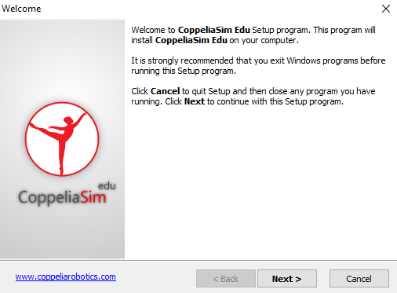

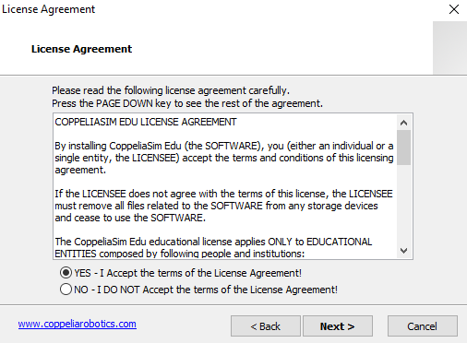

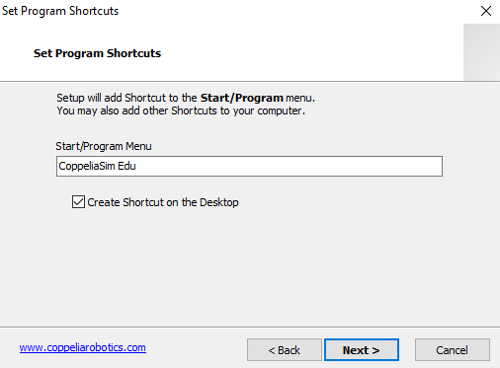

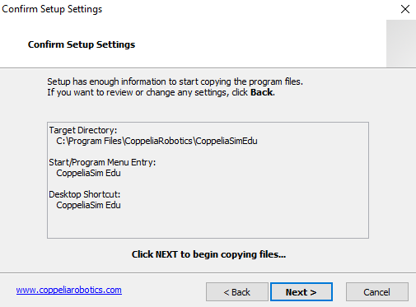

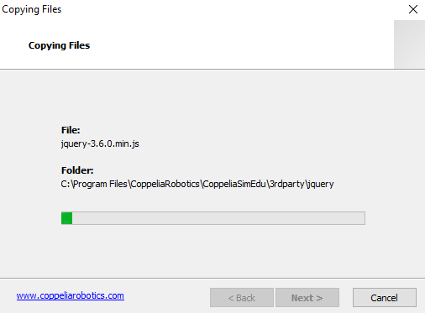

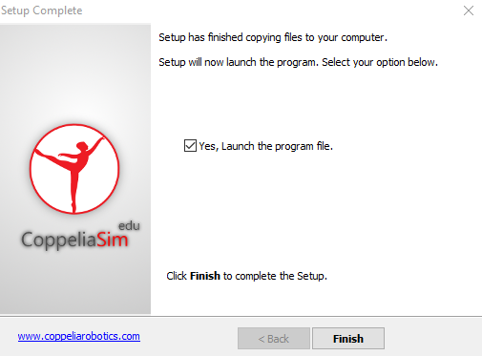

1. After installation, run the software. The following scene should open up.

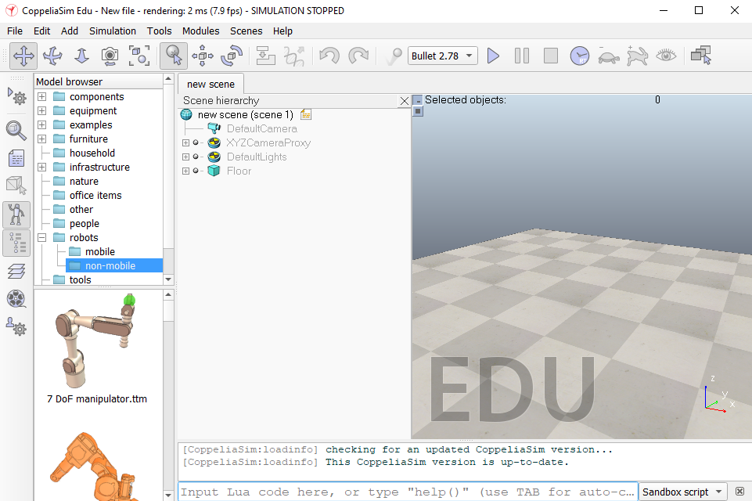

1. We can pick and place any robot from the left side into the simulation environment and watch it in action. For instance,

**Model Browser > robots > mobile > NAO.ttm**

Drag the robot model and place it in the simulation environment.

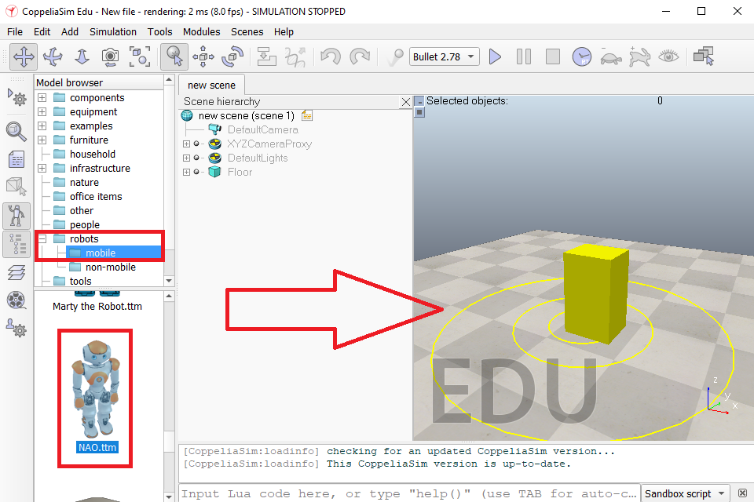

We can see the robot inside the environment. Now hitting the **Play** button will start the simulation and the robot will start operating in a predetermined fashion.

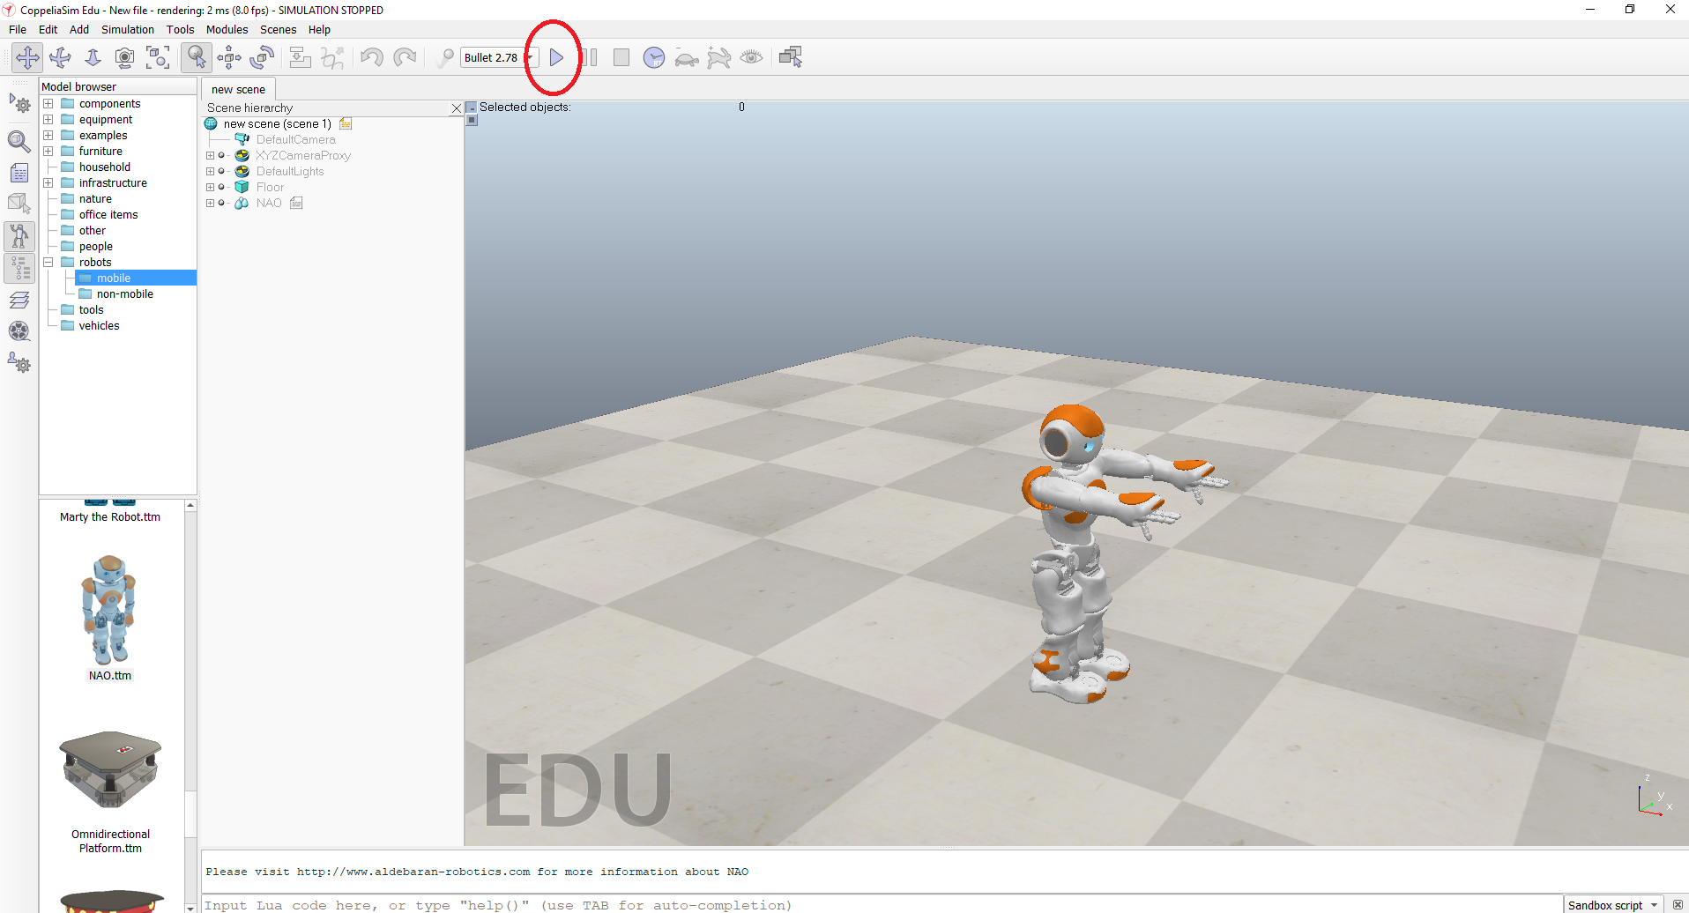

You can use the mouse to look around inside the simulation environment. Feel free to play around with the other robot models!

## B. Installing Anaconda (Python) - Optional

CoppeliaSIm is a versatile software that has APIs for controlling the simulation via Python, MATLAB/Octave, C/C++, Java or the in-built Lua script. We can use any of these to run our simulations.

For running simulations with Python, we need to download and install it onto the system. There are multiple ways of doing it, here we are using **Anaconda** with **Jupyter** notebook as it is one of the most versatile ways for installing python packages and experimenting while coding.

1. Download link for Anaconda (Python) <https://repo.anaconda.com/archive/Anaconda3-2022.10-Windows-x86_64.exe>
2. Following the screenshots below,install anaconda to your windows system. ***Make sure Anaconda is added to the system path during installation.***

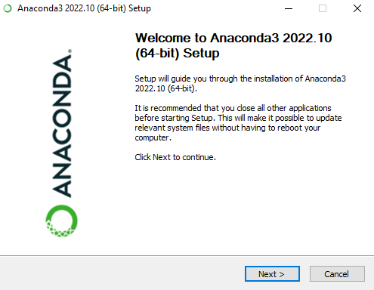

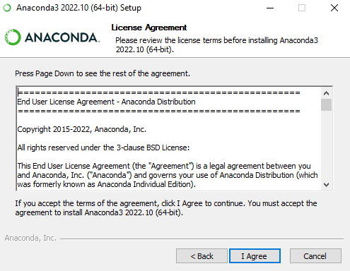

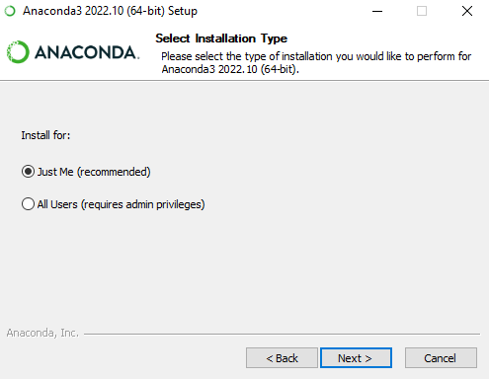

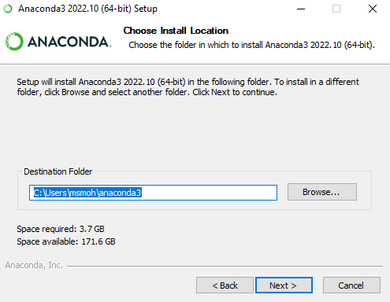

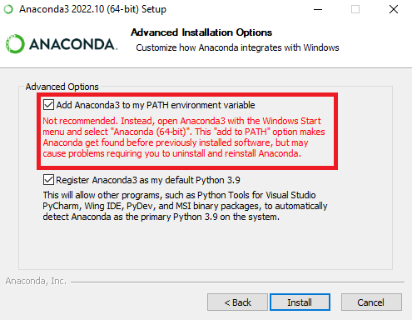

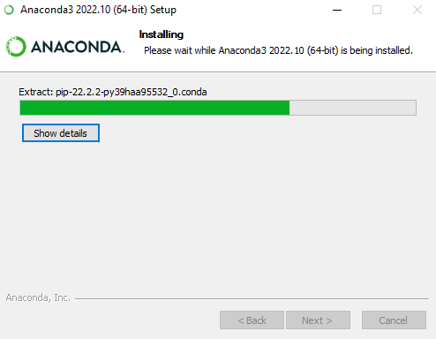

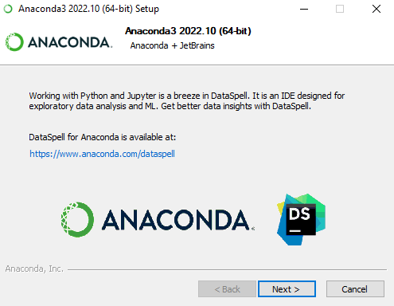

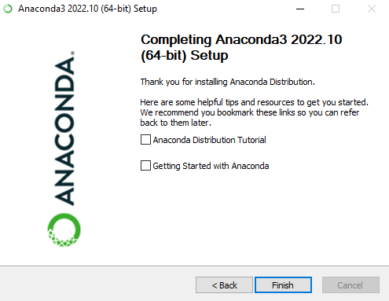

1. After installation completes, we have to use the windows command line and create a new conda environment to run python. ***Make sure Anaconda was added to the system path during installation.***

Open cmd.exe (terminal for linux users).

In the command window, run the following command to create a new environment named “coppelia” - we can change this to any name desired.

conda create -n coppelia python=3.7

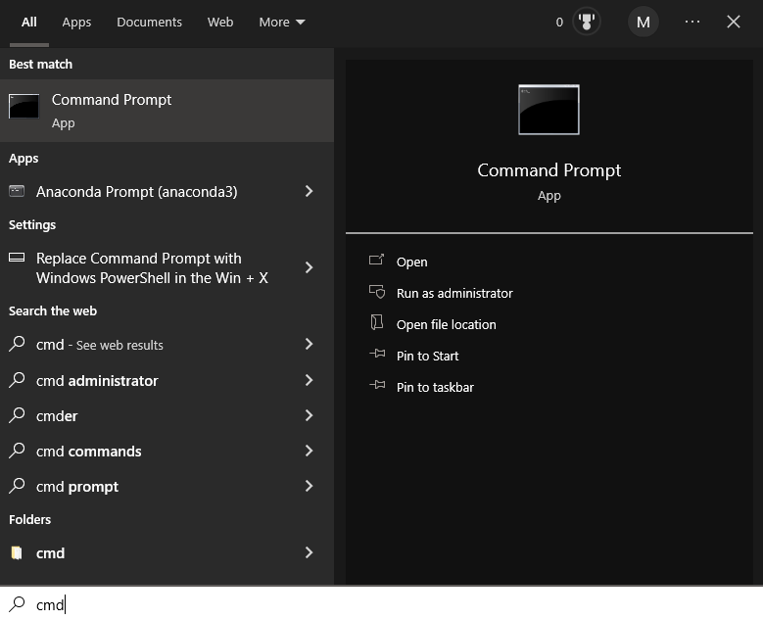

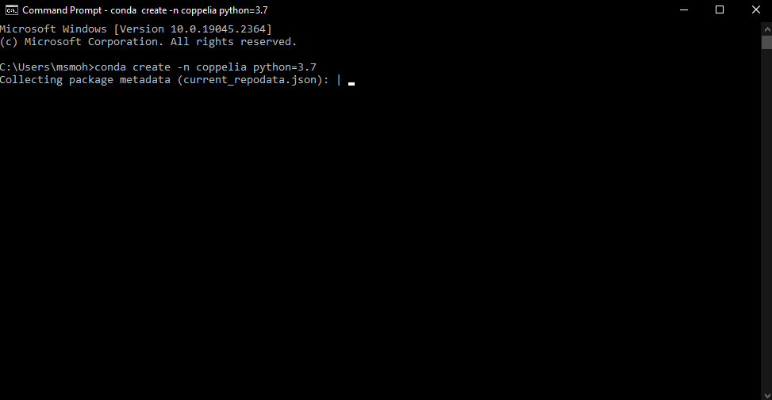

Type “y” and hit enter

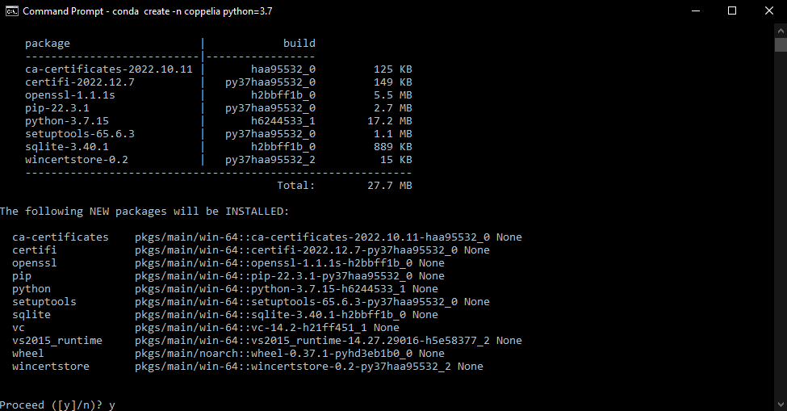

1. After creating the environment, we need to activate the environment and install required packages.

conda activate coppelia



The packages to be installed are numpy, matplotlib, pandas, tqdm, scipy and opencv. Jupyter needs to be installed for using python notebook.

pip install numpy matplotlib pandas tqdm scipy

conda install -c conda-forge opencv

conda install -c anaconda jupyter

1. We can now open jupyter notebook and run python.

jupyter notebook

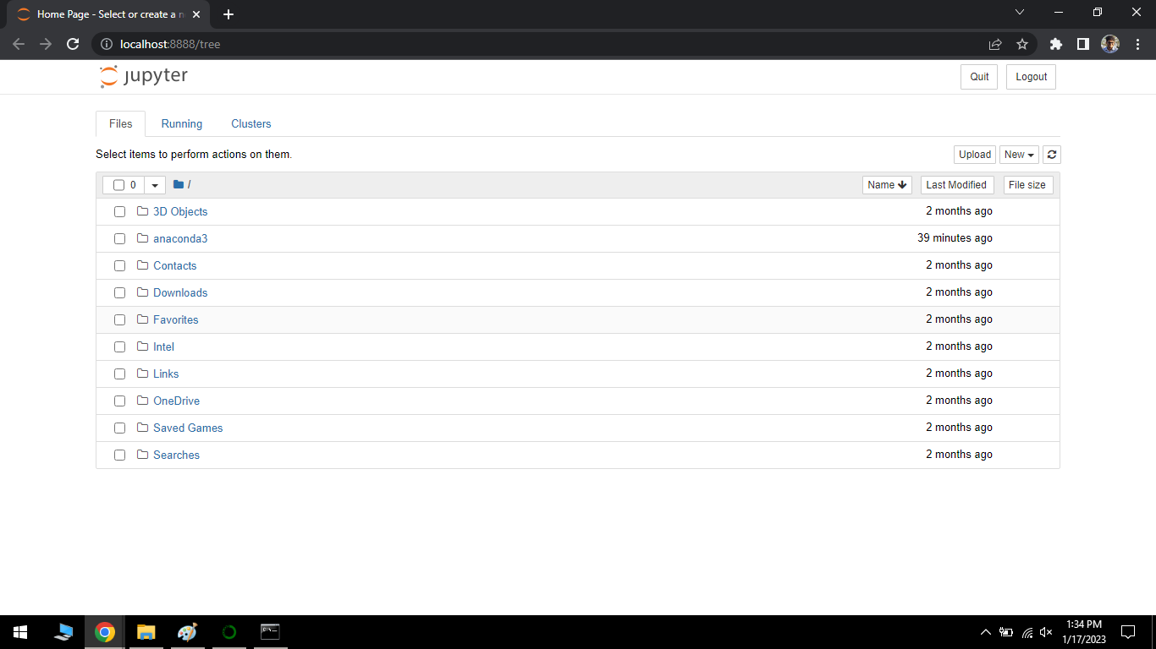

1. Jupyter opens in the current directory of the command window. Each time a new command window is opened, we have to first activate our conda environment and then run jupyter notebook.

conda activate coppelia

jupyter notebook

## C. Installing MATLAB - Optional

CoppeliaSIm is a versatile software that has APIs for controlling the simulation via Python, MATLAB/Octave, C/C++, Java or the in-built Lua script. We can use any of these to run our simulations.

Download and install a recent version of MATLAB to your system. (Steps not included)

# Some Useful Online Resources

1. **Nikolai K**- <https://www.youtube.com/watch?v=w68jmN1IBpo&list=PL38P7Q24q4XA7c0uNj0kO4or-bKhFYdIg>
2. **Mechatronics Ninja**- <https://www.youtube.com/watch?v=9X8QVcuJvQ4&list=PLudgArkgf6tT27_fSvINo-s2nTk8Al380>
3. **Lepoldo Armesto**-

<https://www.youtube.com/watch?v=PwGY8PxQOXY&list=PLjzuoBhdtaXOoqkJUqhYQletLLnJP8vjZ>

\*\**Please note- CoppeliaSim API and codes are version sensitive, some changes in the code might be required in order to make use of older tutorials*\*\*